**Genetics**

**Genetics and Diversity**

**Learning Outcomes:**

* **I can describe how genetic diversity accounts for differences between individuals, species and ecosystems.**

**Biodiversity**

* every living organism –
* this genetic uniqueness creates a biodiversity that can be compared at 3 different levels

1. Genetic Diversity

* any 2 humans have a genetic similarity of approximately 99.7%
* all of the differences between any 2 people only accounts for 0.3% of their DNA

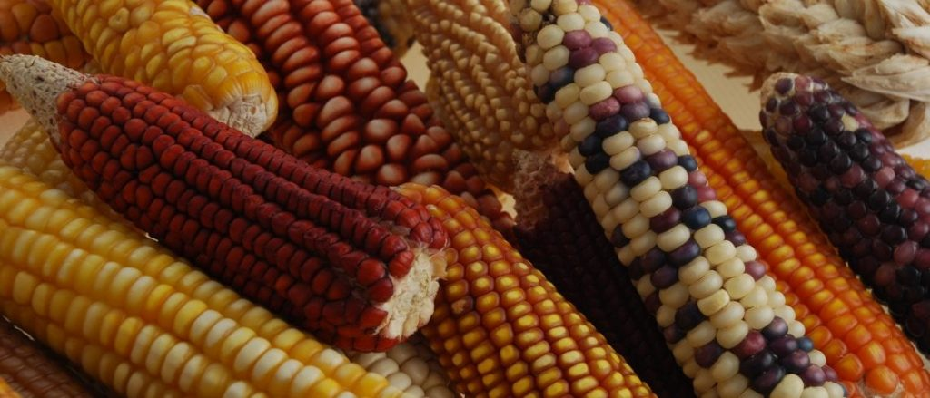

1. Species Diversity

* fruit fly has 4 pairs of chromosomes
* dogs have 39 pairs of chromosomes
* scientists have catalogued over 1.74 million different living species
* estimates on the total number of species ranges from 8.7 million to 1 trillion

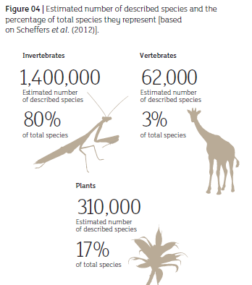

1. Ecosystem Diversity

* ecosystems are composed of both living and non-living components
* means that there is variation between 2 different boreal forests within BC

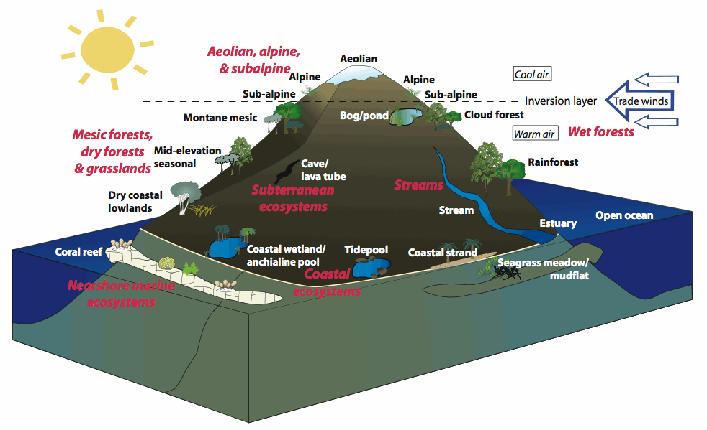

**Videos**

<https://www.youtube.com/watch?v=XOxsjdB4-ZQ>

Bill Nye Biodiversity <https://www.youtube.com/watch?v=65pqsW2EzU0> (use with worksheet)