**Cell Cycle and Mitosis Notes**

**Key Concepts**

* **I can explain that all eukaryotic cells reproduce by the cell cycle.**

**The Cell Cycle**

* Divided into 3 stages.

1. __________________: cells carry out functions necessary for survival and cells that divide prepare for reproduction.
2. Mitosis: divides the duplicated contents of the cell’s nucleus into two equal parts
3. Cytokinesis: separates the two nuclei and cell contents into two daughter cells

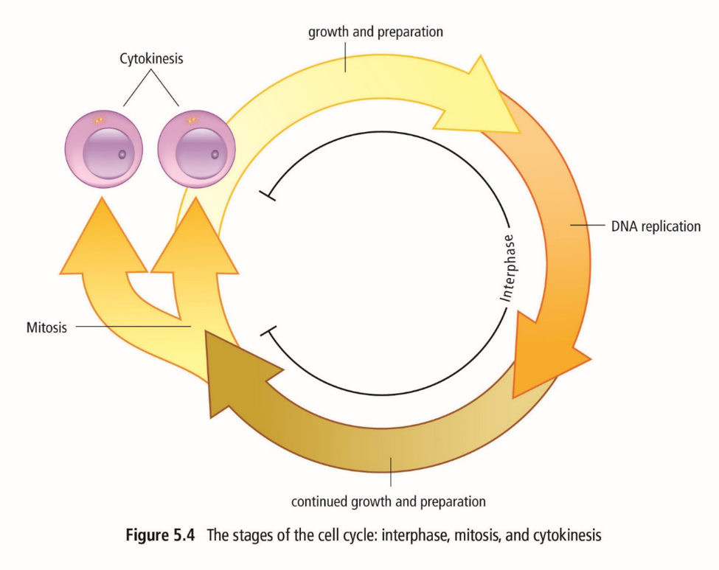

**_____________________**

* Longest stage in the cell cycle.
* During interphase, the cell roughly doubles everything in its cytoplasm.
* Early in interphase, the cell increases in size and makes the proteins and molecules necessary for the cell to function. Some organelles begin to duplicate.
* DNA then copies or makes a “replica” of itself in a process called replication.
* To replicate itself, the two sides of the DNA ladder break apart and each side becomes a template where a new side forms.
* The process results in two new DNA molecules.

**Mitosis**

* The next and usually shortest stage.
* The process in which the contents of a cell’s nucleus divide.
* This division results in two daughter nuclei, each with the same number and kinds of chromosomes as the original cell.
* Consists of the following phases: prophase, metaphase, anaphase and telophase.

**Stages of Mitosis**

Early Prophase - nucleolus disappears and spindle fibres form.

Late Prophase - spindle fibres attach to centromeres of chromosomes.

Metaphase - chromosomes align on equator of cell.

Anaphase - spindle fibres pull sister chromatids to opposite poles of cell.

Telophase - in this final stage, spindle fibres disappear and a nuclear membrane form around each separated set of chromosomes.

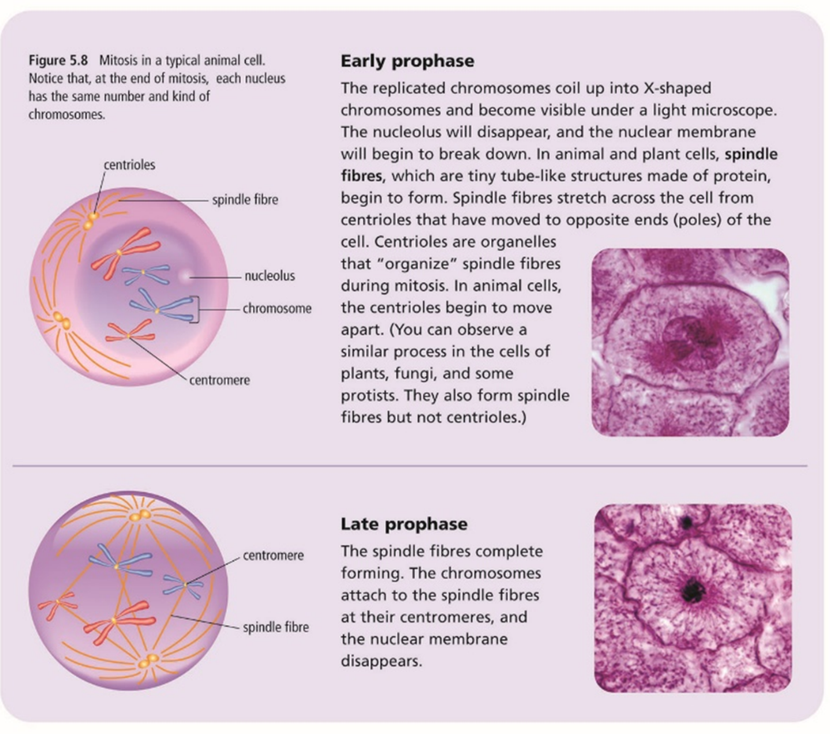

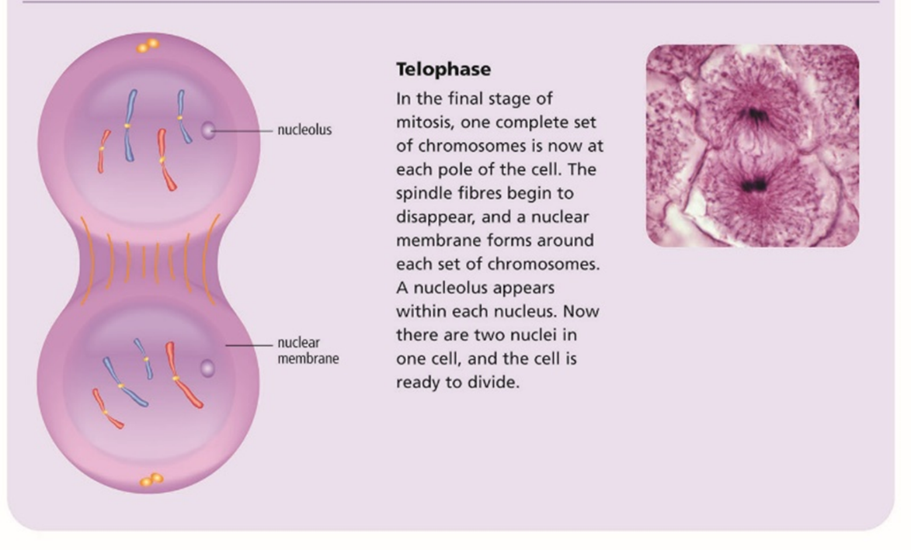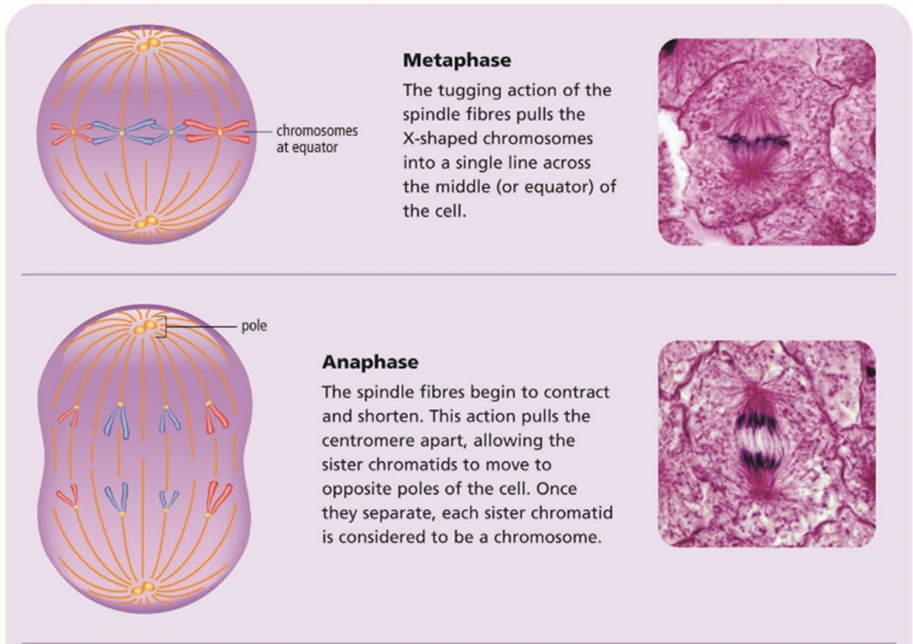

**__________________**

* The final stage.
* Separates the two nuclei into two daughter cells.
* The new cells are genetically identical to the original parent cell.