**Bacterial Reproduction**

**Key Concepts**

* **I can explain how bacteria reproduce by binary fission.**

**Prokaryotic Cells**

* A prokaryotic cell does not have a separate nucleus.
* In addition to lacking a nucleus, they are simpler than the other type of cells.
* They have fewer internal structures.

**Bacteria are prokaryotic cells**

* Has a cell wall, cell membrane, DNA, and ribosomes.
* Some have flagella.
* Bacteria is in, on, and all around us.
* Bacteria used to make cheese and yogurts (dairy products).
* Bacteria in the digestive tract help to break down plant products and make vitamins.
* Found in hot springs.
* Diseases like strep throat are caused by bacteria.
* Bacteria can rot teeth.

**Reproduction by Binary Fission**

* Binary Fission: a type of asexual reproduction in which a cell splits into two daughter cells that have identical genetic information (DNA)
* One cell becomes two independent, identical cells.

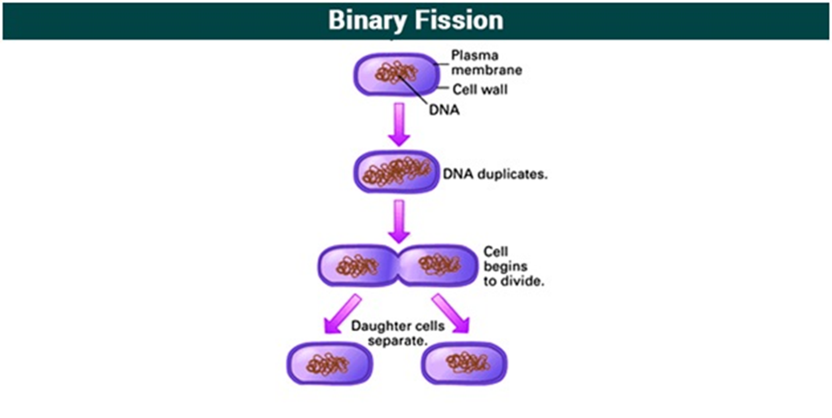

**Exponential Growth!**

* Every time bacteria reproduces, the number of bacteria doubles.

**Questions:**

1. If a population of bacteria starts with one bacterium and divides every 15 minutes. How many bacteria will we have after an hour?
2. If a population of bacteria starts with one bacterium and divides every 10 minutes. How many bacteria will we have after 2 hours?