**Science 9 Course Outline**

****Mrs. King Winter 2024 Semester

**Email:** [aking@sd57.bc.ca](mailto:aking@sd57.bc.ca)

**Office Hours:** Wednesday Tutorial Blocks or by appointment

**Class Website:** <https://mrsanitaking.opened.ca/>

**Welcome to Science 9!**

**Course Description**

Science 9 is a junior science course that gives students the opportunity to explore many science topics. It is an action-packed course that examines themes centered in Biology, Chemistry, Physics, and Earth Science.

**Grades breakdown:**

Extending-4

Proficient-3

Developing-2

Extending-1

Insufficient Evidence- IE

**Materials Needed Everyday:**

1. Pencils / paper

2. 2-inch Binder with dividers for your classes

3. Pencil case with pencil crayons or markers, pencil sharpener, glue

4. Scientific Calculator

5. Class textbook

**How to do well in this class:**

1. Attend class regularly → Skipping class is the #1 reason why students fail

2. Ask for help if you don’t understand

3. Put your phone away unless being used as a study tool

4. Make sure that you keep up with completing class work

5. Study for tests and quizzes

6. Catch up or keep up with missing assignments when you are/will be away

7. Attend Office Hours to catch up or get extra help

**Classroom Policies**

***Attendance***

It is so important to attend class everyday. Should you miss a class, you are responsible for catching up on class notes and assignments. Extra copies of worksheets and notes keys are available in the class mailboxes. If ahead of time you will be absent (for sports or vacations), please let me know in advance.

***Cell Phones***

There will be opportunities to use cell phones and technology in class for Kahoot! review  sessions, Quizlet flashcard review time, research blocks etc. Outside of this time, phones and  headphones should not be out. Students are expected to demonstrate responsibility regarding  cell phone usage.

***Cheating and Plagiarism***

Students are expected to always submit their own work and their own ideas. Students caught cheating will be at risk of severe disciplinary consequences (see PGSS student handbook) and may risk getting an IE (insufficient evidence) for that portion of the class.

***Food and Drinks***

Food and drinks are NOT permitted on lab days. Students may place their food and water in their backpacks or at a side table. Please be responsible for your own mess made in the classroom.

***Late or Missed Assignments***

You are responsible for staying on top of assignments and deadlines. If the assignment is to be assessed by me, you have 1-week or until I have handed back the assignment graded (whichever is later) to complete the missed work. Assignments that are for completion will be reviewed and marked as a class and will not be collected for grading.

***Missed Labs***

Labs are very important components to this course. They will mostly be scheduled on a Tuesday or Thursday due to time constraints. Labs missed for a valid and excusable reason will be excused no more than 2 times in a semester. The pre-lab work MUST still be completed. Students who have missed more than 2 labs, or students who have not been excused for their absence must make up this evidence of learning at lunch or during tutorial.

- Show up for class on time

- Come prepared for class with all supplies

- Act respectfully and responsibly

- Keep headphones and cellphones in your backpack during

lessons and instruction

**Course Break Down**

**Content (to know)**

**Unit 1: Intro to Science**

- Lab Safety

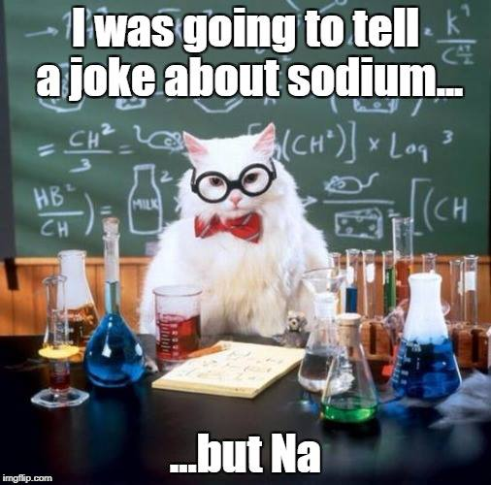- The Scientific Method

**Unit 2: Biology**

- Asexual reproduction

- Sexual reproduction

- Mitosis and Meiosis

**Unit 3: Chemistry**

- The Periodic Table

- Elements and compounds

**Unit 4: Physics**

- Circuits

- Voltage, current and resistance

**Unit 5: Earth Science**

- Matter cycles in biotic and abiotic

systems

- First peoples knowledge about

interconnectedness and sustainability