**Genetics**

**Chromosomes**

**Learning Outcomes:**

* **I can explain how DNA, chromatin and chromosomes are linked.**
* **I can explain the difference between genes, traits and alleles.**
* **I can explain what a karyotype is.**

## Terminology

* DNA – _____________________________________________________________________
* Genome – __________________________________________________________________
* Chromosome – ______________________________________________________________
* Gene – _____________________________________________________________________
* Allele – ____________________________________________________________________

## Chromatin and Chromosomes

* During normal cell activity (interphase), _________________________ form long fibres called ______________
* At the start of ______________, the chromatin fibres condense to form ________________
* Human DNA is collected into ______ chromosomes that form ______chromosomal pairs.
* each pair consists of one chromosome from ______________________
* There are ___________________________________in human DNA
* 22 paired homologous chromosomes
* X chromosome – paired in females & only one in males
* Y chromosome – single one in males only paired to an X chromosome
* in humans, each of the _____ paired chromosome codes for between 2058 genes (chromosome 1) and 234 genes (chromosome 21)
* ___________________ codes for 842 genes
* ____________________only codes for 71 proteins – results in “sex-linked” traits

**Homologous Chromosomes**

* homologous chromosomes are pairs of chromosomes that are similar in:
  + ____________
  + _________________________
  + _________________________________________

## Genes

* ___________________________________________________________________________
* alleles – variations in a gene that results in differences in individuals

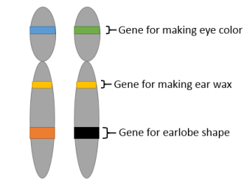

1. _____________________________

* traits controlled by one gene sequence with only 2 alleles
* ex: hair line, hitch-hiker’s thumb, PTC paper

1. ______________________________

* traits controlled by one gene sequence with more than 2 alleles
* ex: blood type

1. _______________________________

* traits controlled by multiple genes sequences
* ex: eye colour, hair colour, height

1. ________________________________

* traits affected by the presence or absence of the Y chromosome
* ex: colour blindness, baldness

**Karyotypes**

* refers to the number and appearance of paired chromosomes from a eukaryotic cell
* often shown as a photograph

