**Genetics**

**DNA**

**Learning Outcomes:**

* **I can describe the basic structure and function of DNA.**

Structure

* first observed in 1869 by the German biochemist Frederich Miescher
* did not realize the importance of the molecule he had found
* discovery of the structure of structure of DNA:
* Maurice Wilkins (1950) – first used X-ray diffraction on ram sperm to try to discover the shape of DNA
* Rosalind Franklin (1952) – extended the work of Wilkins to produce a higher quality X-ray diffraction image
* James Watson & Francis Crick (1953) – used the information from Wilkins and Franklin to hypothesize a correct model of the shape of DNA
* Looks like a twisted ladder 🡪 called a ________________________
* ____________________________ groups make up the “sides” of the ladder
* _____________________________ make up the steps/rungs
* 1 sugar, 1 phosphate group and 1 nitrogenous base is called a _________________
* 4 different nucleotides that are identified by the nitrogen base

|  |  |
| --- | --- |
| Adenine (A) ----- Thymine (T) | called Complimentary Base Pairing |
| Cytosine (C) ----- Guanine (G) |

Example: Strand 1 A T A A C G T C A

Strand 2

* Human DNA is composed of around 3 billion nucleotides on __________________________

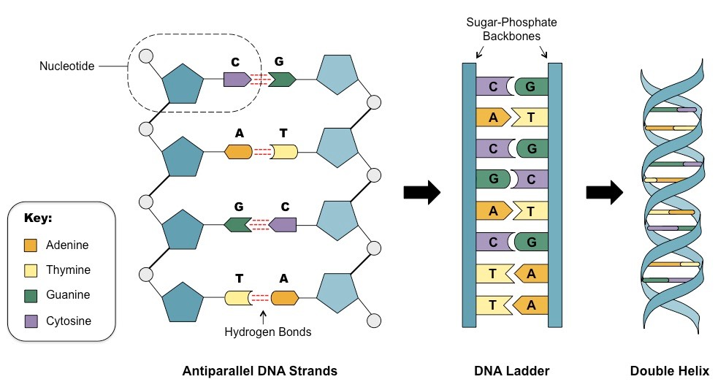

## DNA Function

* DNA codes for the blue prints of life 🡪 it is an information molecule
* each nucleotide is a _________________
* a sequence of nucleotide monomers is a ______________________
* each DNA polymer codes for a specific ____________ or other gene
* each DNA polymer is divided into a _____________________subsection called a ___________
* each codon translates into an ______________
* a chain of amino acids forms a ____________
* there are approximately 20,000 protein-coding genes and another 5,000 other genes in human DNA
* these may vary slightly between individuals 🡪 results in differences between individuals
* ____________________________________________________________________________________________________________________________________

**Build and Pair a DNA Strand**

1. Students will each randomly pick one strand of DNA.
2. Students will build their DNA sequence out of coloured mini marshmallows, toothpicks and a piece of licorice (or other types of candy).
3. Once built, students will need to compare their DNA strand against other students’ DNA to find the opposite matching half of DNA.
4. When a match has been found, students will call the teacher over to verify their match.
5. Once verified, students can eat their half of DNA.